8-BIT MULTIPLICATION OPERATIONS USING 8085 MICROPROCESSOR
AIM:
To write an assembly language program to multiply two numbers of 8-bit data stored in memory 4200H and 4201H and store the product in 4202H and 4203H.
APPARATUS REQUIRED:
- 8085 microprocessor kit 1
- Power card 1
- Keyboard 1

ALGORITHM:
- Load the first data in ACC and move to E.
- Load the second data ACC and move to B (count)
- Clear HL pair (Initial sum)
- Clear D for overflow (carry)
- Add the content of DE to HL
- Decrement the count.
- Check whether the count has reached zero.
- Check the zero flag. If ZF = 0, repeat addition or If ZF = 1, go to next step
- Store the content of HL in memory. (Least significant 16 bits of the product)
- Stop.

Output:

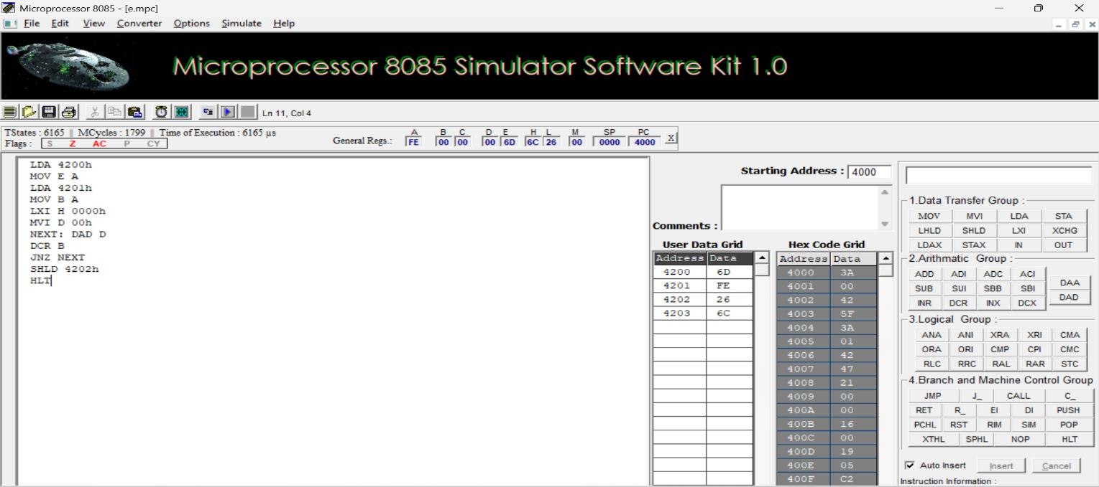

RESULT:

Thus, an assembly language program to multiply two numbers of 8-bit data was written, executed and Verified the Result successfully using 8085 kit.

AIM:

